Subject Line: Upload photos when you book with us!

Hi,

We’re very excited to announce that our Online Booking system now lets you add photos!

Either upload a photo when making a booking or log into your Online Booking account and add photos of the looks you love. We’re excited about this addition to our system as we’ll know what you want before your visit!

Here’s what the new system looks like:

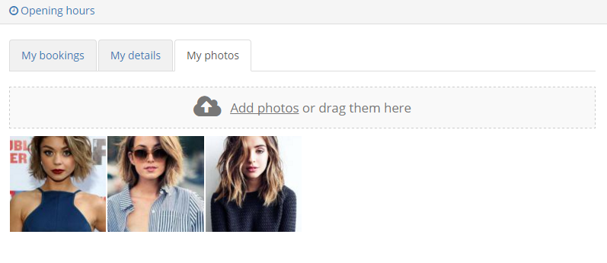

From,

