Email template:

Hi customer first name,

Hope you’re having a lovely week :) If you make bookings using Online Booking, you’ll notice things look a little different. You can make a booking at any time, on any device (your mobile or tablet etc.). If you haven’t given Online Booking a go, now’s the time to try it out. We think it’s great!

To make a booking today, visit #Website#.

We look forward to seeing you soon.

#Business Name#
#Phone number#
#Website#

Facebook post: (Set up your book now button)

Using Online Booking to make appointments? You’ll notice some exciting changes! You can make a booking at any time, on any device (mobile, tablet etc.), and it’s easy than ever.

If you haven’t given Online Booking a go, now’s the time to try it out. Hit the book now button above!

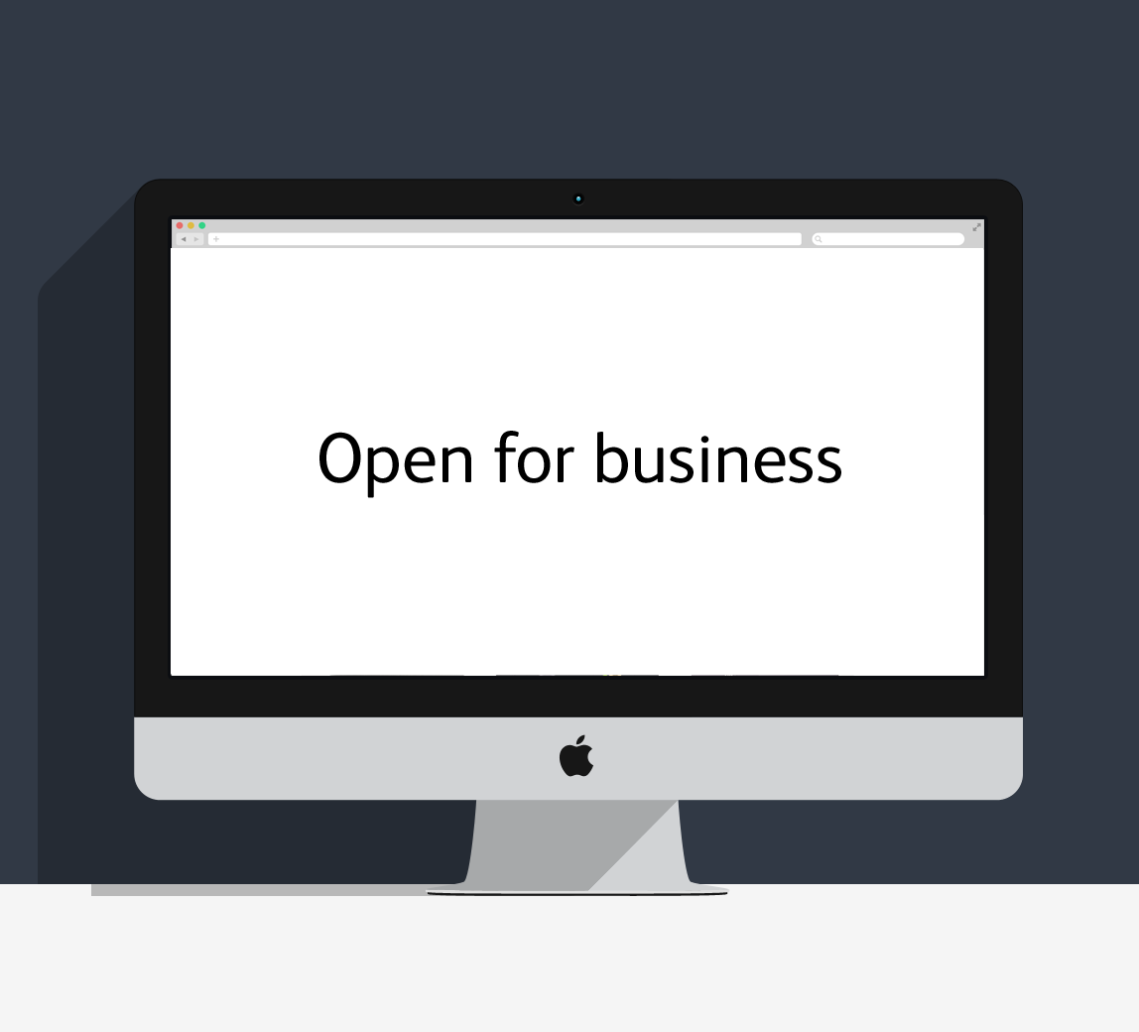
Twitter post:

Our Online Booking page has had a facelift! Check it out and start using it today to make your appointments. You’ll love it

